|  |  |  |
| --- | --- | --- |
| **AI 2002 Artificial Intelligence**  **Course Instructor**  **Ms. Mahzaib Younas** | | |
| **Time allowed = 60 min** | **Quiz 3** | **Total Marks = 60** |

**BCS Section A**

|  |
| --- |
| _____________________ ______________ . .  __________________ **Roll No Name Signature** |

**Question No 01:** The figure below represents aone-dimensional state-space landscape in which elevation corresponds to the objective function.Fill in the following state space landscape with the correct labels. **[5]**

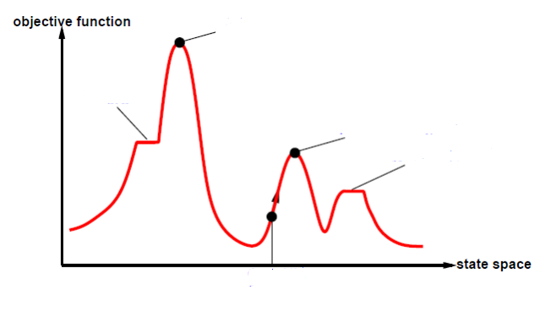

**Question No 02:** Consider the problem of building railway tracks under the assumption that pieces fit exactly with no slack. Now consider the real problem, in which pieces do not fit exactly but allow for up to 10 degrees of rotation to either side of the “proper” alignment. Explain how to formulate the problem so simulated annealing could solve it. **[2 x 3 = 6]**

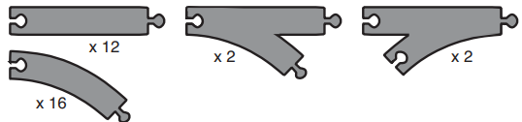

**Question No 03:** For the given problems, which type of hill climbing is the most suitable? **[4]**

1. Stochastic Hill Climbing
2. Steepest Hill Climbing
3. First Choice Hill Climbing
4. Random Start Hill Climbing

|  |  |
| --- | --- |
| **Problems** | **Types of Hill Climbing** |
| Travelling Salesman Problem |  |
| N-Queens Problem |  |
| Maximum Cut Problem |  |
| Graph Coloring Problem |  |

**Question No 04:** In the following, a “max” tree consists only of max nodes, whereas an “expectimax” tree consists of a max node at the root with alternating layers of chance and max nodes. At chance nodes, all outcome probabilities are nonzero. The goal is to find the value of the root with a bounded-depth search. For each of (a)–(f), either give an example or explain why this is impossible. **[10]**

1. Assuming that leaf values are finite but unbounded, is pruning (as in alpha–beta) ever possible in a max tree?
2. Is pruning ever possible in an expectimax tree under the same conditions?
3. If leaf values are all nonnegative, is pruning ever possible in a max tree? Give an example, or explain why not.
4. If leaf values are all nonnegative, is pruning ever possible in an expectimax tree? Give an example, or explain why not.
5. If leaf values are all in the range [0, 1], is pruning ever possible in a max tree? Give an example, or explain why not.
6. If leaf values are all in the range [0, 1], is pruning ever possible in an expectimax tree?

**Question No 05:** Assign the values from the domain to all the given variables such that the assignment satisfies the given constraints and perform the crypt-arithmetic for the given evaluation expression: **[5]**

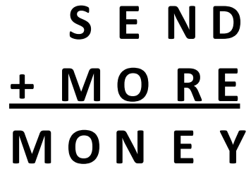

**Variables:** D, E, M, N, O, R, S, Y

**Domains:** Di = {0, 1, 2, 3, 4, 5, 6, 7, 8, 9}

**Constraints:** M ≠ 0, S ≠ 0, D ≠ E, D ≠ M, D ≠ N, Y = D + E OR Y = D + E - 10

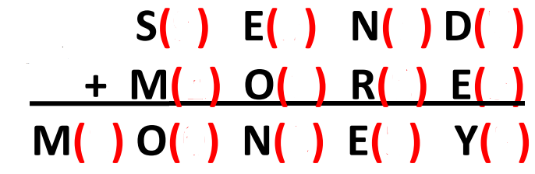

**Question No 06:** Assign the colors to each area keeping in view the remaining legal values for the unassigned variables and maintaining arc consistency. **[7]**



|  |  |  |  |  |  |  |  |
| --- | --- | --- | --- | --- | --- | --- | --- |
|  | WA | NT | Q | NSW | V | SA | T |
| Initial Domains | R G B | R G B | R G B | R G B | R G B | R G B | R G B |
| After WA = red |  |  |  |  |  |  |  |
| After Q = green |  |  |  |  |  |  |  |
| After V = blue |  |  |  |  |  |  |  |

**Question No 07:** Identify the types of constraints based on the given data: **[3]**

1. A ≠ 0
2. A ≠ B
3. E = A + B

**Question No 08:** Identify the variables, constraints, and domains in the given Sudoku problem: **[5]**

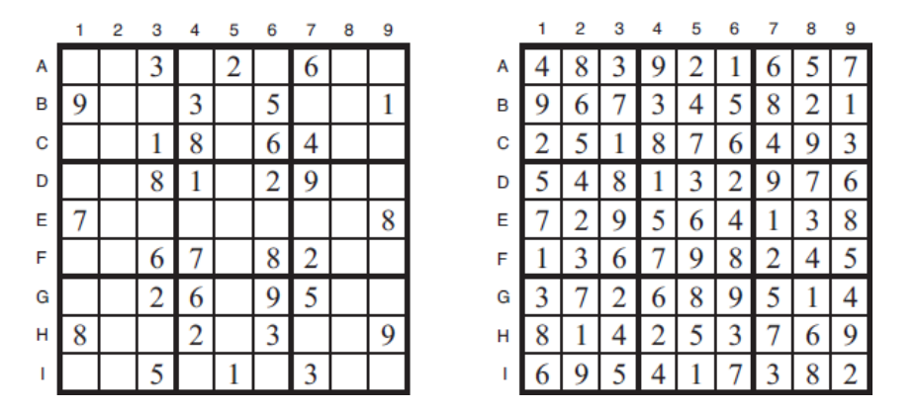

**Variables:**

**Domains:**

**Constraints:**

**Question No 09:** Construct the following truth table: **[5]**

|  |  |  |  |  |  |  |  |
| --- | --- | --- | --- | --- | --- | --- | --- |
| **P** | **Q** | **~ P** | **P ∧ Q** | **P ∨ Q** | **P ⇒ Q** | **Q ⇒ P** | **P ⇔ Q** |
|  |  |  |  |  |  |  |  |
|  |  |  |  |  |  |  |  |
|  |  |  |  |  |  |  |  |
|  |  |  |  |  |  |  |  |

**Question No 10:** Consider the Wumpus world problem as described in the figures below: **[5 x 2 = 10]**

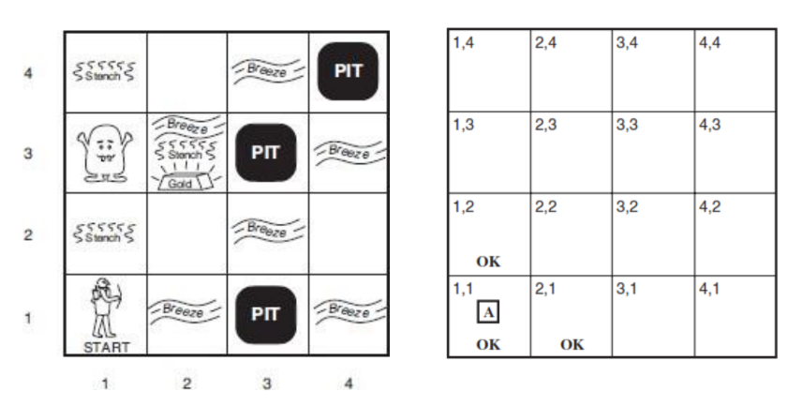

**Given:** A: agent, B: breeze, G: Gold, OK: Safe, P: Pit, S: Stench, W: Wumpus

Using preposition logic, write the expressions to represent the following conditions:

1. If there is a stench in square (1, 2), then there is a Wumpus in an adjacent square.
2. If there is gold in square (2, 3), then there is a breeze and a stench in square (2, 3).
3. There is a breeze in square (3, 2) or there is no pit in square (1, 3).
4. The agent perceives a stench in square (1, 2) if and only if there may be a Wumpus in an adjacent square.
5. If there is a breeze in square (4, 1), then there is a Pit in an adjacent square.

**Best of Luck!**